1. CASIGNIA RUIZ DIEGO ALEJANDRO

inspector: Calvache Gabriel

Rubric:

Classes:

POOExam1P27 1/1

A 1/1

B 1/1

C 1/1

E 1/1

POO - E 1/1

A -> B 0.5/1 Wrong label

A -> B 0/1      No relation

E -> A 0/1 No relation

E -> B 0.5/1 Wrong relation

E -> C 0/1 No relation

C -> B 0.5/1 Wrong relation

TOTAL: 7.5/10

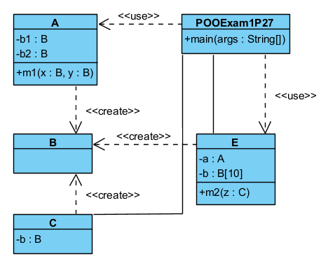

1. GALARZA VILLALVA CESAR LUIS

inspector: Calvache Gabriel

Rubric:

Classes:

POOExam1P27 0/1 Wrong attribute and methods

A 0.5/1 Wrong methods

B 1/1

C 1/1

E 0.5/1 Wrong methods

Relations:

POO - E 0.5/1 Wrong Relation

A -> B 0.5/1 Wrong Label

A -> B 0.5/1 Wrong Relation

E -> A 0/1 No relation

E -> B 1/1

E -> C 0.5/1 Wrong label

C -> B 0.5/1 Wrong relation

TOTAL: 6.5/10

